Safety information
This chapter describes the requirements and measures that must be implemented to ensure risk-free operation.

  - Purpose of safety information
Safety information warns of hazards that could lead to bodily injury or damage to property. Always read and follow safety instructions to prevent accidents and injuries from occurring.

The following signal words indicate the category of the hazard and the extent of the danger.

DANGER!
This signal word indicates a direct risk leading to death or severe injury.
WARNING!
This signal word indicates a potential risk that could lead to death or severe injury.
CAUTION!
This signal word indicates a potential risk that could lead to slight or minor injury.
NOTICE!
This signal word indicates a potentially damaging sit‐ uation that could lead to damage to the machine or objects in its vicinity.

  - Intended use
The machine is intended for the following applications only:
- Use in the food and beverage industries.
- Production of sturdy packs of bottles or cans by gluing. Specific restrictions:
- Certified hot-melt glue can only be obtained through KHS.
- Machine must only be operated with clean and dry products.

Use of the machine is considered in accordance with its intended use only if the operator adheres to the following items:
- Use as described in the operating manual
- Use within the limits specified in the technical data
- All activities are carried out only by qualified and trained personnel
- Those persons not working on the machine must keep a safe distance from hazardous and operating areas
- Use of spare and wear parts that comply with specifications for original parts
- Replacement of wear parts within the specified replacement inter‐ vals

  - Reasonably foreseeable misuse
KHS will not be held liable for damage resulting from misuse of the machine.
The following are considered misuse:
- Any use above and beyond proper use
- Alterations or modifications without the knowledge and consent of KHS are considered not proper use
- Circumventing or removing safety devices and safeguards

- Processing of products that are not detailed in the ‘Technical data’ chapter, in particular living organisms
- Combinations of the KHS machine with external machines

  - Obligations of the operator
The operator undertakes to implement measures arising from content in the technical documentation. This includes in particular:
- Compliance with laws and regulations currently applicable at the site.
- Clearly marking hazardous areas.
- Training and instructing personnel.
- Providing personal protective equipment.
- Enforcing prohibitory and mandatory rules.
- Ensuring devices to secure the shut-off elements are fitted.
- Ensuring signs warning against uncontrolled reactivation are pro‐ vided.

  - Personnel requirements
Personnel must be qualified to operate and maintain the machine.
This operating instructions assigns activities to the following per‐ sonnel:
Personnel:  Operating personnel
- Maintenance personnel
- Laboratory personnel
- KHS personnel.
- Remote access personnel

WARNING!
Personnel who do not meet the requirements
Danger of injury when carrying out operating and main‐ tenance activities.
This can lead to severe or even fatal injury.
– Activities may be undertaken only by personnel who are assigned to the tasks and meet the requirements.

The only personnel deemed authorised are those who fulfil the fol‐ lowing requirements:
- They have reached the statutory minimum age for the site.
- Their following capabilities are neither temporarily nor perma‐ nently impaired:
  - Thinking and acting
  - Seeing
  - Hearing
  - Reacting
  - Moving
  - Lifting and carrying
- They fulfil the statutory health and safety requirements that apply to the site with regard to processing materials and the products being manufactured.
The following capabilities, knowledge and skills are also essential: Basic capabilities
- Average intellectual capacity
- Average spatial awareness
- Average hand-eye coordination
- Manual dexterity
- Technical understanding

- Understanding of spoken statements
- Understanding of texts Basic knowledge and skills:
- Hydraulics
- Quality control, quality assurance
- Maintenance, repair work, servicing
Machine-related capabilities, knowledge and skills:
- Functions of the machine and its systems
- Operating method and technical specifications of the machine and its systems
- Operating controls on the machine
- Control program
- Safety instructions
- Basic hygiene regulations

KHS personnel.
KHS personnel have been specially trained and authorised to perform these activities by KHS.
KHS service personnel
KHS service personnel are KHS personnel who are specially trained in carrying out these activities.
Laboratory personnel
In addition to the general requirements, laboratory personnel must also meet the following requirements:
Basic capabilities
- Average abstract logical thinking
- Average analytical thinking
- Observational accuracy
- Sustained alertness when monitoring
- Dexterity
- Manual skills
- Competency in planning and organising
- Competency with numbers Basic knowledge and skills:
- Completion of secondary education
- Food processing job training recognised at the installation site or equivalent job experience (with certificate)
- At least one year of work experience in the beverage and pack‐ aging industry
- Microbiological testing
- Chemical, biochemical, microbiological and technical analysis and measurement methods

- Laboratory work, laboratory technology
- Food hygiene
- Food testing
- Sampling
- Quality checks and quality assurance
- Documentation
- Health certificate in accordance with §§ 42 and 43 IfSG [German Infection Protection Act];
- Laboratory control software
- Food chemistry
- Food legislation
- Food technology
- Microbiology
- Recipes
Machine-related capabilities, knowledge and skills:
- Training and instruction in the area of application specified for the intended use
- Training and instruction in the safety instructions and hygiene reg‐ ulations
Maintenance personnel
In addition to the general requirements and the requirements set forth for operating personnel, maintenance personnel must also meet the following requirements:
Basic capabilities:
- Average abstract logical thinking
- Average analytical thinking
- Observational accuracy
- Dexterity
- Manual skills
- Competency in planning and organising
- Competency with numbers
- Oral communication skills Basic knowledge and skills:
- Completion of secondary education
- Specialised job training recognised at the installation site for car‐ rying out maintenance and servicing activities or equivalent job experience (with certificate)
- Electrical engineering (electronics, electromechanics, electrical installation, mechatronics)
- Automation technology (hardware and software installation, infor‐ mation and computer technology, PLC technology and program‐ ming, coding)
- Microelectronics (bus systems, microcomputers and microproces‐ sors)

- Work preparation
- Hybrid control systems
- Measuring, control and regulating equipment (MSR)
- Microelectronics (microcomputer and microprocessor technology)
- Pneumatics
- Test field
- Robots and handling technology
Machine-related capabilities, knowledge and skills:
- Training and instruction in terms of servicing and type change
- Training and instruction in the safety instructions and hygiene reg‐ ulations
- Special training and instruction in maintenance and servicing activities
Operating personnel
In addition to the general requirements, operating personnel must meet other requirements:
Basic capabilities:
- Sustained alertness when monitoring
- Ability to adapt
Basic knowledge and skills:
- General education
- Activity-related job training recognised at the installation site or equivalent job experience (with certificate)
- At least one year of work experience in the beverage and pack‐ aging industry
- Knowledge of manufacturing technology
- Knowledge of machine control and operation
- Knowledge of machine equipment
- Knowledge of pneumatics
Machine-related capabilities, knowledge and skills:
- Training and instruction in the area of application and the opera‐ tion specified for the intended use
- Training and instruction in the safety instructions and hygiene reg‐ ulations
Remote access personnel
In addition to the general requirements and requirements that apply to maintenance personnel, remote access personnel must also meet the following requirements:
Component-related capabilities, knowledge and skills:

- Training and instruction by KHS in the requirements and use of remote access
- Maintenance technician or maintenance personnel user role for identification on the operator console

  - Protective equipment
Persons remaining or working in the vicinity of hazardous and oper‐ ating areas are required to wear general or special personal protec‐ tive equipment.
CAUTION!
If personal protective equipment is not available or not worn
Risk of injury if personal protective equipment is not worn.
This could cause slight or minor injury.
– Wear personal protective equipment prescribed.
General personal protective equipment:
- Work clothes
- Safety shoes with toe-protection caps and non-slip soles
- Protective gloves
- Safety goggles
- Hearing protection suitable for the noise level
Clothing must be close fitting, particularly on the arms. Long hair be protected by a hairnet or suitable headgear.
If special personal protective equipment is required, this is indicated immediately before the description of the relevant activities in the operating manual.

  - Hazardous areas and identification of these areas
The prohibitory signs, warning signs and mandatory signs described in the following are posted on the machine. They pertain to the imme‐ diate vicinity in which they are posted and are intended to protect personnel.

WARNING!
Removed or illegible marking of hazardous areas
If signs are removed or illegible, hazardous areas will not be recognised, mandatory rules will be ignored and prohibitory rules will not be observed.
This could result in severe or fatal injury.
- Never remove warning signs.
- Replace lost, removed or damaged warning signs immediately.
- Replace or clean illegible warning signs immedi‐ ately.

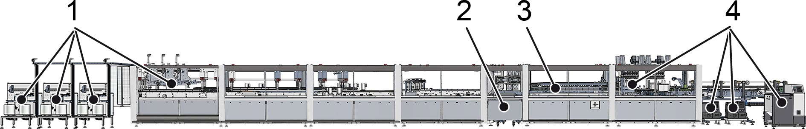

Figure 2: Hazardous areas

 | Hazardous area | Risk type | Risk source
 | Entire machine | Risk of burns | Hot surfaces on the motors
 | Pre-melting unit | Risk of burns | Pre-melting unit  Hot-melt glue hoses
 | Pre-melting unit | Risk of irritation of the air‐ ways | Hot-melt glue vapours
 | Switch cabinet | Electric shock | Electrical current
1 | Adhesive tape station | Risk of lacerations | Adhesive tape cutter
1 | Adhesive tape station | Danger of collision | Protruding components
1 | Adhesive tape station | Risk of becoming trapped | Rotating arms
2 | Ejection | Risk of becoming trapped | Rejection container
3 | Changing station in the "Sealing" process module | Risk of being pulled into the machine; risk of becoming trapped | Format sets
4 | Hot-melt glue station Hot-melt glue units | Risk of burns | Hot-melt glue units Hot-melt glue hoses  Hot-melt glue application heads  Sprayed hot-melt glue drops
4 | Hot-melt glue station Hot-melt glue units | Risk of irritation of the air‐ ways | Hot-melt glue vapours

    - Prohibitory signs Do not walk on this area.


Access forbidden for unauthorised persons.


Do not reach into the danger area.

    - Warning signs Warning – hazardous area.


Warning — hot surface.


Warning – hand injuries.


Danger of lacerations.



Warning of laser beam.

Warning – electrical voltage.


Warning of automatic start-up.

    - Mandatory action signs
Disconnect the component from the power supply before carrying out maintenance or repair work.

Wear hand protection.

Wear foot protection.

Wear hearing protection.


Wear eye protection.

  - Safety equipment
DANGER!
Bypassed safety equipment
There is a risk of fatal injury from bypassing safety equipment such as safety doors, protective grating and guard plates, light barriers, control facilities, load lim‐ iters, initiator switches, safety valves, and emergency stop switches, and from rendering such equipment inoperable.
This could cause severe and even fatal injury.
- Do not remove permanently installed safety equip‐ ment while operating the machine.
- Never start up the machine without the safety equipment in place.
- Use safety equipment to prevent inadvertent bodily contact with the machine.
- Note that safety equipment will automatically shut down the machine in the event of a malfunction.

    - Safety circuits
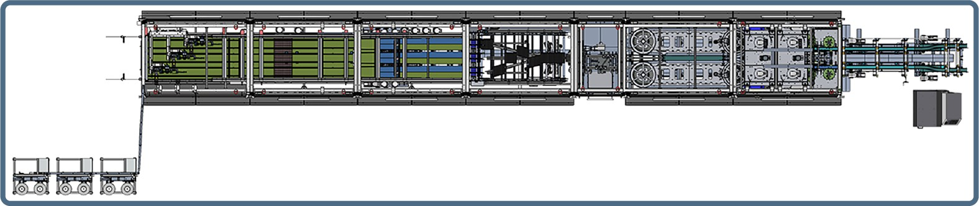
Figure 3: "Machine emergency stop" safety circuit

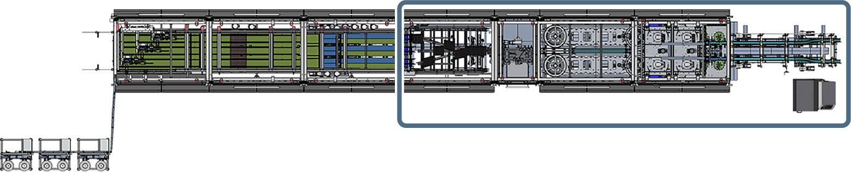

Figure 4: "Safety equipment" safety circuit, front machine section

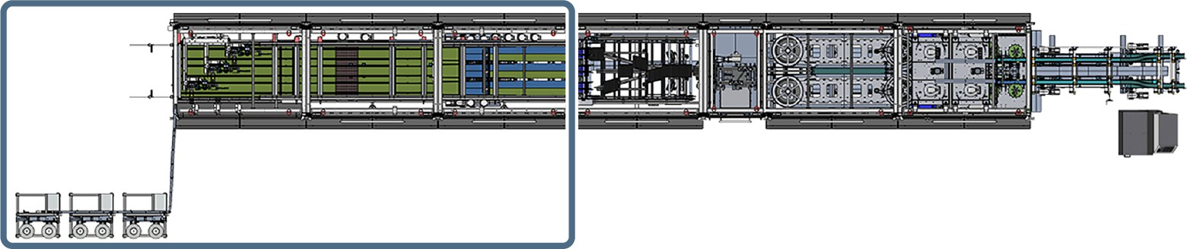
Figure 5: "Safety equipment" safety circuit, rear machine section

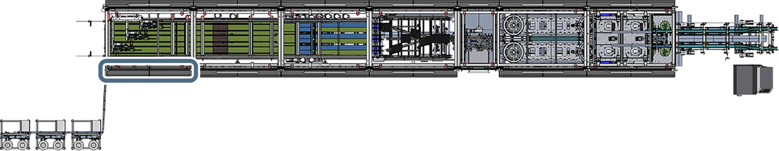

Figure 6: "Safety equipment" safety circuit, safety light curtain in the "Carrying handles" process module

Safety concept for the "Machine emergency stop" safety circuit
The emergency stop switches are connected to a safety control system via two channels. The safety control system monitors the emergency stop switches.
In the event of an emergency stop, electrical drives are shut down as quickly as possible using stop category 1. Depending on the drive type, the drives are shut down in one of the following ways:
- Disconnection of the power supply via dual power contactors, e.g. in the case of three-phase drives.
- Activation of integrated safety functions such as Safe Torque Off (STO), e.g. in the case of servo drives and drives with frequency converters.

Safety concept for the "Safety equipment" safety circuit, front machine section
Transponder-coded safety switches with an electromagnetic locking mechanism perform a non-contact check of the isolating safety devices in the front machine section. They are connected to the safety control system via two channels and are monitored by the safety control system.
If a safety device in the front machine section is opened, electrical drives in the front machine section are shut down as quickly as pos‐ sible using stop category 1. Depending on the drive type, the drives are shut down in one of the following ways:

- Disconnection of the power supply via dual power contactors, e.g. in the case of three-phase drives.
- Activation of integrated safety functions such as Safe Torque Off (STO), e.g. in the case of servo drives and drives with frequency converters.

Safety concept for the "Safety equipment" safety circuit, rear machine section
Transponder-coded safety switches with an electromagnetic locking mechanism perform a non-contact check of the isolating safety devices in the rear machine section. They are connected to the safety control system via two channels and are monitored by the safety control system.
If a safety device in the rear machine section is opened, electrical drives in the rear machine section are shut down as quickly as pos‐ sible using stop category 1. Depending on the drive type, the drives are shut down in one of the following ways:
- Disconnection of the power supply via dual power contactors, e.g. in the case of three-phase drives.
- Activation of integrated safety functions such as Safe Torque Off (STO), e.g. in the case of servo drives and drives with frequency converters.

Safety concept for the "Safety equipment" safety circuit, safety light curtain in the "Carrying handles" process module
A safety light curtain monitors the opening on the operator side in the "Carrying handles" process module. The safety light curtain is con‐ nected to the safety control system via two channels and monitored by the safety control system.
If the safety light curtain in the "Carrying handles" process module is interrupted, electrical drives in the "Carrying handles" process module are shut down as quickly as possible using stop category
- Depending on the drive type, the drives are shut down in one of the following ways:
  - Disconnection of the power supply via dual power contactors, e.g. in the case of three-phase drives.
  - Activation of integrated safety functions such as Safe Torque Off (STO), e.g. in the case of servo drives and drives with frequency converters.

    - Safety devices with actuation elements
The machine has the following safety devices with actuation ele‐ ments:
- Emergency stop switch
- Safety doors
- Repair switches (not on all machines)
- Safety light curtain in the "Carrying handles" process module (not on all machines)
- Container in the "Ejecting" process module (not on all machines)
For detailed information on the safety equipment, see the ‘Safety equipment’ section in the chapter entitled ‘Operation’.

    - Fixed separating safety equipment
Fixed, detachable safety equipment is permanently attached to the machine and prevents personnel from reaching into the machine.

      - Protective screen at machine infeed
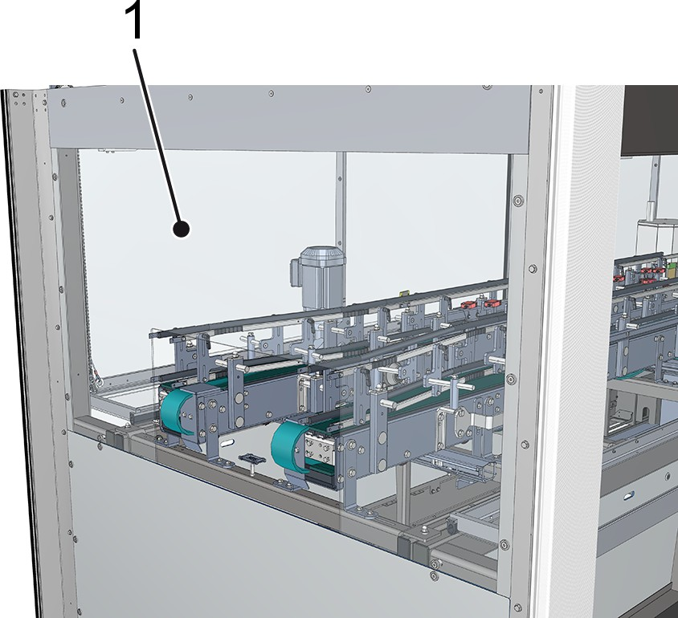
Figure 7: Machine infeed
1 Protective screen
The protective screen at the machine infeed prevents anyone from reaching into moving parts of the "Product feed" process module.

      - Protective panelling
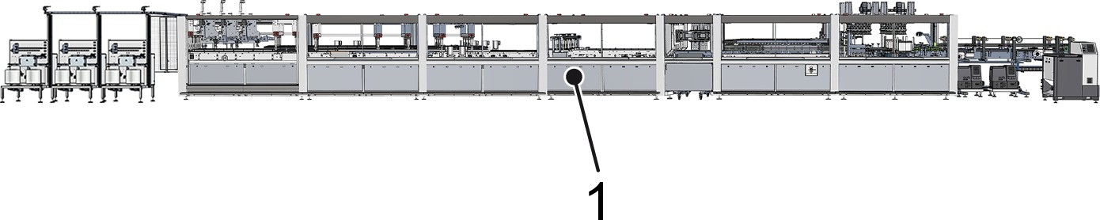
Figure 8: Machine side view (example)
1 Protective panelling
Protective panelling is located on the side of the machine, below the conveyor level and on the front sides of the machine in the infeed and outfeed. The protective panelling prevents entry into the machine.

      - Protective screen at the machine outfeed
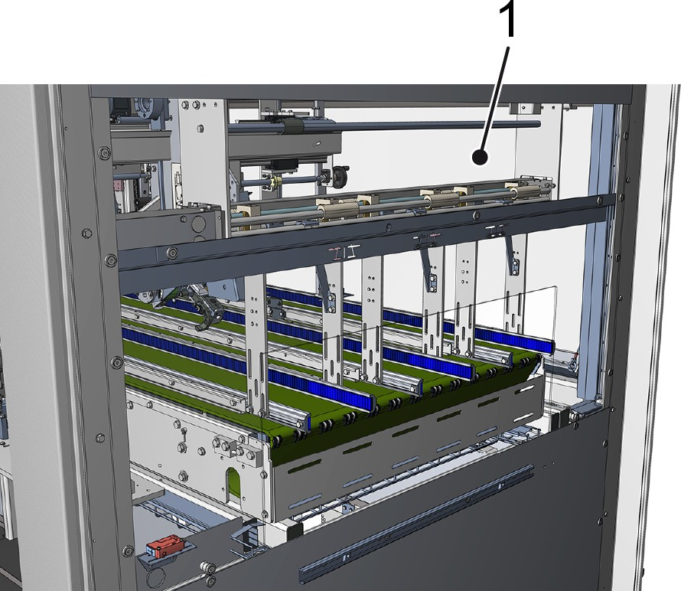
Figure 9: Machine outfeed
1 Protective screen
The protective screen at the machine outfeed prevents contact with the moving parts of the process module at the machine outfeed.

  - Conduct in hazardous situations and in the event of an accident
Observe the following regulations to ensure proper and safe conduct in emergency situations and in the event of accidents:
- Local accident prevention regulations
- Local emergency regulations
- Local workplace safety regulations

Notes on emergency situations
Check the following before performing work on the machine:
- What dangers does the machine pose?
- How can these dangers be avoided?
- How should personnel act in case of emergency, e.g. stop the machine, first aid measures?
- Where is the required emergency equipment at the site located,
e.g. first-aid kit, fire extinguisher?
- What emergency facilities are available and where are they, e.g. fire alarms, escape routes?

Procedure in case of accident

- Shut down the machine.
- Switch off both main switches on the switch cabinet and secure with a padlock.
- Initiate the internally specified first aid measures.
- Report the accident to a responsible person.

  - Operating statuses and operating modes
The machine has various operating statuses and operating modes:
- Deenergised machine
- Operating status Off
- Operating status On
  - Automatic operating mode
  - Operating mode Setup
  - Teleservice operating mode
The operating modes differ in their safety functions and allow activi‐ ties with access to hazardous areas.

    - De-energised machine
The machine is disconnected from the power sources. The residual energy is dissipated and the machine is secured against being switched on again.
For information about how personnel can de-energise the machine, see the chapter entitled ‘Servicing’, ‘Disconnecting and securing’ section.
Personnel:  Maintenance personnel

This is intended for the following activities:
- Routine servicing
- Limited repairs

    - Operating status Off
The control voltage is disconnected and the operating controls are stopped. No operating functions (jog, teach, etc.) can be performed.

    - Operating status On
The control voltage is switched on and the operating controls and operating functions are activated. Manually controlled operating func‐ tions (jog, teach, etc.) can be performed depending on the operating mode.

      - Automatic operating mode
The machine is connected to the power sources. The safety functions guarding against dangerous machine functions are fully effective.
For instructions on how to switch on the Automatic operating mode, see chapter ‘Operation’, section ‘Preparing for operation’.
Personnel:  Operating personnel
        - Maintenance personnel
The following activities are intended:
- Supply of equipment
- Minor interventions for troubleshooting
- Minor maintenance activities

      - Setup operating mode
The machine can be operated with specific operating functions, and is connected to the power sources. The safety functions guarding against dangerous machine functions are partly effective.
There is an increased risk of residual hazards.
For instructions on how to switch on the Set-up operating mode, see chapter ‘Servicing’, section ‘Set-up operating mode’.
Personnel:  Maintenance personnel The following activities are intended:
        - Setup
        - Maintenance tasks

      - Teleservice operating mode
The machine is connected to the power sources. All operating func‐ tions can be executed. The safety functions guarding against dan‐ gerous machine functions are fully effective in every operating func‐ tion.
For instructions on how to switch on Teleservice mode, please see
‘Faults’, ‘Operating mode Teleservice’.
Personnel:  Maintenance personnel
        - Remote access personnel
        - KHS service personnel
This is intended for the following activities:
- Remote diagnostics and remote access for determining and recti‐ fying faults

  - Residual risks
The machine may still have residual hazards, even when it is utilised for its intended use, despite all the design, construction and control technology measures.
The following section designates the residual hazards which will be ascertained from KHS .
Always adhere to the listed safety instructions and the safety instruc‐ tions in the additional chapters of this instruction documentation to prevent any safety hazards and dangerous situations.
Since 06/27/2018, lead (CAS no. 7439-92-1) has been on the SVHC (Substances of Very High Concern) candidate list under the Euro‐ pean chemical regulation REACH. Very small amounts of lead are present in the electrical and electronic components of this machinery. This lead will not be released if the machine is used for its intended purpose. The affected components have been coated with a finish or the lead is contained in an alloy. National regulations for the handling and disposal of lead and materials containing lead must be observed.

CAUTION!
Concussions and lacerations
Danger of impact injuries and lacerations from pro‐ truding components.
This could cause slight or minor injury.
– Extreme caution must be exercised in the vicinity of these components.
CAUTION!
Irritants
Risk of injury if lubricants or other irritants come into contact with the skin, eyes, and mucous membranes.
This could cause slight or minor injury.
- Avoid contact between lubricants and other irritants and the skin, mucous membranes, and eyes.
- Observe the safety instructions.
- Use protective equipment.

CAUTION!
Hot surfaces
During operation, motors reach temperatures that would cause burns on contact.
This could cause slight or minor injury.
- Wear protective gloves when carrying out any work near hot surfaces.
- Observe cooling time.
- Observe the safety instructions.
CAUTION!
Heavy carrying handle spools
Loading the machine with carrying handle spools may require particular physical strain.
This could result in slight or minor injury.
– When loading the machine with carrying handle spools, avoid any physical strain.
CAUTION!
Ergonomically unfavourable posture
Scales that are difficult to read and control points that are hard to access can mean that setting and main‐ tenance work involves ergonomically unfavorable pos‐ tures.
This may result in slight or minor injury.
– When performing setting and maintenance work, take appropriate breaks.
CAUTION!
Working on drive components
Failure to carry out proper repairs on the drive compo‐ nents may cause the function of the safety devices to be permanently impaired.
This affects both the hardware (e.g. servo motors) and the software (firmware of servo control).
This could cause slight or minor injury.
All work on drive components may only be performed by specially trained personnel.

CAUTION!
Hot glue
Heating the hot glue produces vapour which can lead to irritation if inhaled for prolonged periods.
This may result in slight or minor injury.
- Avoid inhaling the vapour for long periods.
- Only open the pre-melting unit tank to refill it and close it again immediately.
- Keep the tanks of the hot glue devices closed.
WARNING!
Pressurized components
Danger as a result of leakage of pressurized liquids and gases.
This could result in severe or fatal injury.
- Check pressurized lines.
- Observe maintenance specifications.
- Ensure that the permitted operating pressure is maintained.
WARNING!
Moving and rotating components
Risk of injury from moving and rotating components. Danger of entanglement, entrapment, crushing, and cutting.
This could result in severe or fatal injury.
- Before starting, ensure that no one is in the danger area.
- Do not reach into moving or rotating machine parts during operation.
- Maintain a safe distance from moving or rotating machine parts during operation.
- Only perform repairs, maintenance work, cleaning and disassembly when the machine is de-ener‐ gised.

WARNING!
Adhesive tape knife
The adhesive tape knife is very sharp. Risk of punc‐ tures, ruptures or cuts.
This could result in death or serious injury.
- Wear cut-resistant protective gloves.
- Observe warning information on the machine.
WARNING!
Residual energy when the machine is switched off There is a risk of injury after switching off the machine from the inertia of moving parts and other residual energy.
This could result in severe or fatal injury.
When faults occur, components are not always able to return to their end positions and retain residual energy (potential energy). When rectifying faults, components may begin to move uncontrollably in order to reduce their residual energy.
- After pressing the emergency stop button, bear in mind the inertia of moving parts.
- Secure and de-energise the machine before car‐ rying out any work on the machine.

WARNING!
Setup operating mode
Setup mode disables some of the safety equipment. Some motors and valves are not secured.
In the "Sealing" process module, format sets can be conveyed in the area of the change stations even though the safety doors are opened.
Risk of injury at moving and rotating parts. This could result in death or serious injury.
- Only use Setup operating mode for replacing format sets in the "Sealing" process module.
- Only the operating personnel that replace the format sets are permitted to remain in the vicinity of the machine.
- The operator who moves the format sets is respon‐ sible for the safety of all persons involved.
- Switch off the machine first, then open the safety doors.
- Once work is complete, immediately switch off Setup operating mode.
WARNING!
Risk of burns – hot gluing station
Risk of burns on the surfaces of hot glue devices, hot glue hoses and hot-melt application heads.
Risk of burns due to hot glue in the tank of the hot
glue devices and the hot glue that is sprayed out by the hot-melt application heads.
This could result in death or serious injury.
- Do not touch hot surfaces.
- Wear safety goggles and protective gloves when working on the hot gluing station.

WARNING!
Risk of burns at the pre-melting unit
Risk of burns on the surfaces of the pre-melting unit and the hot glue hoses.
Risk of burns due to hot glue in the tank of the pre- melting unit.
This could result in death or serious injury.
- Do not touch hot surfaces.
- Wear safety goggles and protective gloves when working on the pre-melting unit.
DANGER!
Electrical current
Danger of electric shock from live machine parts. This could lead to severe or even fatal injury.
- Do not touch live parts when the machine is switched on.
- Contact an authorised electrician to work on the electrical equipment.
- Switch off the main switch before working on the electrical equipment.
- Secure the main switch with a padlock.

